小盾管理APP / SDUN APP

苹果/IOS
https://itunes.apple.com/cn/app/id1378871238
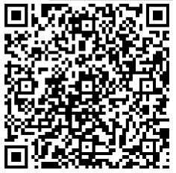​

安卓/Android
http://app.dgsdun.com:8080/app/LockManager-release.apk
